DBSCAN
Teaching Notes
A from-scratch guide to density-based clustering, written for someone who has never seen it before. Builds directly on the K-Means and Hierarchical Clustering notes: same goal (grouping similar points), a genuinely different way of getting there.

Contents

1. Two Problems K-Means and Hierarchical Clustering Share
Both K-Means and Hierarchical Clustering, for all their differences, share two assumptions that don't always hold:
- Every point must belong to some cluster. Neither method has a way to say “this point doesn't really fit anywhere,” an outlier gets forced into whichever cluster happens to be nearest, quietly distorting that cluster's statistics.
- Clusters are implicitly assumed to be a reasonably compact, “blobby” shape. K-Means explicitly measures distance to a single center point; Hierarchical Clustering is more flexible but still tends to produce round-ish groups with common linkages like Ward.
DBSCAN (Density-Based Spatial Clustering of Applications with Noise) is built specifically to fix both of these: it can trace out clusters of any shape, and it has a built-in concept of “noise”, points that just don't belong anywhere.

2. The Core Idea: Density, Not Distance-to-Center
Instead of asking “how far is this point from a cluster's center?”, DBSCAN asks “how many other points are packed in close around this one?”. A cluster, in DBSCAN's view, is simply a region where points are densely packed together, connected to their neighbors, who are connected to their neighbors, and so on, however far and in whatever shape that chain happens to wind.
This idea rests on just two numbers you choose upfront:
- eps (ε): how close two points need to be to count as neighbors of each other.
- min_samples: how many neighbors (within eps) a point needs to have to count as being in a dense region.
Every point then falls into exactly one of three roles:
- Core point: has at least min_samples neighbors within eps of it. This is a point solidly inside a dense region.
- Border point: doesn't have enough neighbors itself to be core, but sits within eps of a core point. It gets pulled into that cluster, but (unlike a core point) it can't pull in any further neighbors of its own.
- Noise point: neither of the above. It's not densely surrounded, and it's not close enough to anything that is. It gets left out of every cluster entirely.
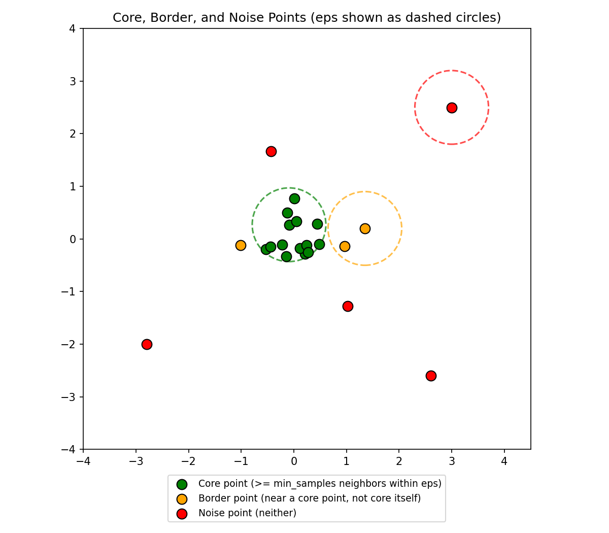
Figure 1. Core (green), border (orange), and noise (red) points, with eps shown as dashed circles around one example of each.
A cluster is built by starting at a core point, then repeatedly adding any point within eps of an already-included core point (and, if that new point is itself core, continuing to expand from it too). This chaining is exactly what lets clusters take on long, curved, irregular shapes, the cluster only cares about local density along the way, never about distance to some fixed center.

3. Seeing the Difference: DBSCAN vs. K-Means
The clearest way to see why this matters is on data shaped like two interleaved crescents, plus a handful of scattered points that don't belong to either, exactly the kind of shape K-Means' “distance to a single center” assumption breaks on.
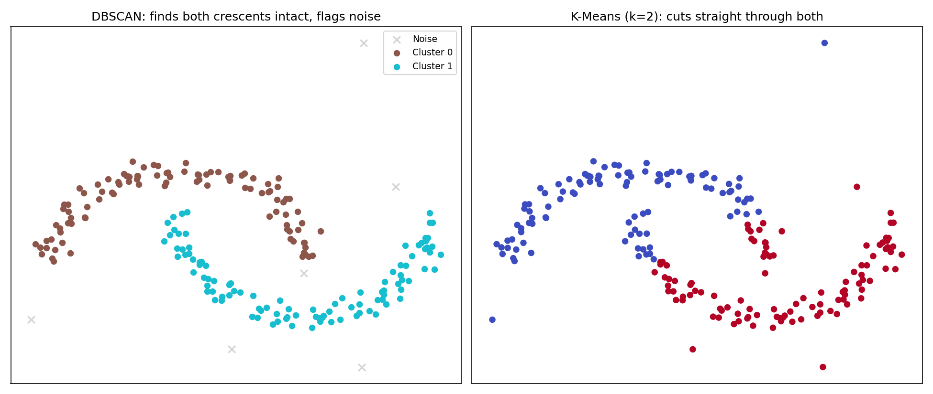
Figure 2. DBSCAN correctly recovers both crescents intact and flags the scattered points as noise. K-Means, forced to use straight-line distance to two centers, cuts directly through both crescents instead.
K-Means isn't making a mistake here, it's doing exactly what it's designed to do: minimize distance to two center points. The shape of the true clusters simply isn't something that objective can represent. DBSCAN never computes a “center” at all, so it has no trouble with the curve.

4. Choosing eps: the k-Distance Plot
min_samples is usually the easier choice, a common starting rule of thumb is min_samples ≥ (number of features) + 1, often simply doubled for noisy data. eps is trickier, and there's a standard, principled way to choose it rather than guessing:
- For every point, find the distance to its min_samples-th nearest neighbor.
- Sort all of these distances from smallest to largest, and plot them.
- Points in dense regions will have a small such distance (their neighbors are close by). Points in sparse regions, or true outliers, will have a much larger one.
- The plot typically stays low and flat, then bends sharply upward, that “elbow” is a good candidate for eps: roughly the boundary between “has enough close neighbors” and “doesn't.”
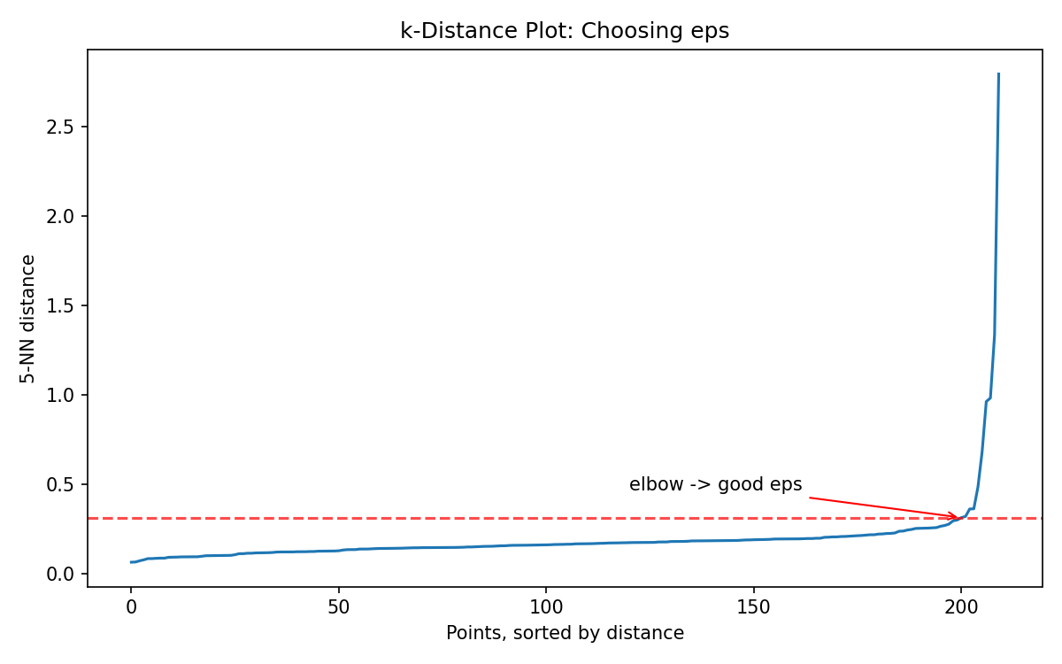
Figure 3. The k-distance plot for the crescents-plus-noise data. The sharp bend near the right edge marks a sensible eps.

5. A Real Weakness: Clusters With Very Different Densities
DBSCAN uses a single, global eps for the entire dataset. That's a problem when different clusters genuinely have different densities, one tight and compact, another naturally more spread out. There is no single eps that correctly describes both at once.
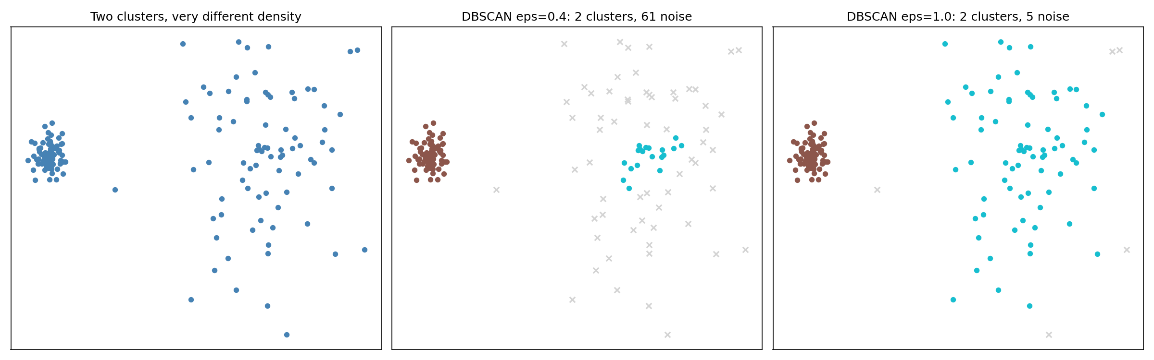
Figure 4. Left: one dense cluster, one naturally sparser one. Middle: an eps tuned for the dense cluster treats most of the sparse one as noise. Right: an eps tuned for the sparse cluster works for both here, but in general, a large enough eps can just as easily start merging a dense cluster with nearby noise instead.
This is a genuine limitation, not a matter of trying harder to find the right eps, no single value may exist if densities differ enough. (Algorithms like HDBSCAN were later developed specifically to relax this single-eps requirement, worth knowing exists, though outside the scope of this note.)

6. Strengths, Weaknesses, and When to Use DBSCAN

Strengths
- Finds clusters of any shape, not just round/compact ones.
- Has a built-in, principled way to identify outliers/noise, rather than forcing every point into a cluster.
- Doesn't require choosing the number of clusters upfront, that emerges from the data and your eps/min_samples choice.

Weaknesses
- Struggles when clusters have meaningfully different densities (Section 5).
- Sensitive to the choice of eps and min_samples, small changes can noticeably change the result, unlike K-Means where k has a more predictable effect.
- Distance becomes a much less meaningful concept in high-dimensional spaces (“the curse of dimensionality”), so DBSCAN, like most distance-based methods, works best on a modest number of features.

Rule of thumb: reach for DBSCAN when you suspect your clusters aren't neat round blobs, or when identifying outliers is itself part of the goal, not just a side effect. Reach for K-Means or Hierarchical Clustering instead when your data is reasonably well-behaved (roughly round, similar-density groups) and you want a fast, predictable method.

7. Summary Cheat Sheet
- DBSCAN groups points by density (how packed together they are), not by distance to a center.
- Every point is core (densely surrounded), border (attached to a dense region, not dense itself), or noise (neither).
- Clusters form by chaining core points together, which is exactly what lets them take on any shape.
- eps and min_samples are the only two parameters, choose eps using a k-distance plot's elbow, min_samples from feature count as a starting point.
- DBSCAN explicitly labels outliers as noise instead of forcing them into the nearest cluster, K-Means and Hierarchical Clustering cannot do this.
- Its main weakness is clusters with very different densities, a single global eps can't describe them all at once.

